Test Models:
Combinational test models will represent the portions of codes that invoke the usage of certain class methods. This decision was due to the fact that there are many different test cases that can be derived by the combinations of the current class attributes. With this approach, any method that relied on class attributes and the combination of user input seemed as viable candidates.

Combinational Test Models

public bool deleteAccount()
Condtion | V1 | V2
Valid Account | True | False

public bool updateAccount()

Condition | V1 | V2 | V3
Update Name | Account found | Account not found
Withdraw Money | Account found && (debit) | Account found && (!debit) | Account Not Found
Deposit Money | Account found | Account not found

public double debit(double newAmount)

Condition | V1 | V2
Attempt Debit | NewAmount > mBalannce | NewAmount <= mBalannce

The following models represent methods that are best represented by state transition trees. They are straight forward with little to no guard conditions. These methods closely resemble state machines in there operations, therefore it seemed reasonable to model them in such a manner.

State Transition tree
public bool createAccount()
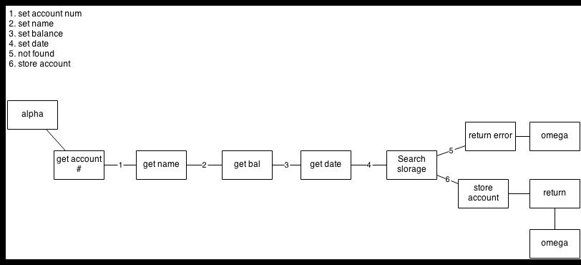

public int findAccount()

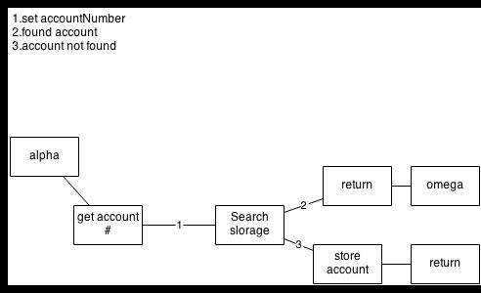

public void runBankApplication()

